Experiment 6: Gradient Descent, SGD, Momentum and Adam Comparison

1. Aim
To implement and compare different optimization algorithms, namely Batch Gradient Descent, Stochastic Gradient Descent (SGD), Momentum and Adam, for training a delivery-time prediction model. To visualize optimizer paths on a two-dimensional loss contour, compare convergence rates using loss-versus-epoch graphs, and analyze the effect of different learning rates using NumPy, TensorFlow, Keras and Matplotlib.

2. Formula(s)
1. Gradient Descent Update Rule: θ(t+1) = θ(t) - α × ∇J(θ(t))
2. Stochastic Gradient Descent (SGD): θ(t+1) = θ(t) - α × ∇Ji(θ(t))
3. Momentum: v(t) = β × v(t-1) + ∇J(θ(t))
θ(t+1) = θ(t) - α × v(t)
4. Adam Optimizer:
First Moment Estimate: m(t) = β1 × m(t-1) + (1 - β1) × g(t)
Second Moment Estimate: v(t) = β2 × v(t-1) + (1 - β2) × g(t)^2
Bias Correction: m_hat(t) = m(t) / (1 - β1^t)
v_hat(t) = v(t) / (1 - β2^t)
Parameter Update: θ(t+1) = θ(t) - α × m_hat(t) / (√v_hat(t) + ε)
5. Mean Squared Error (MSE): MSE = (1/N) × Σ(yi - ŷi)^2
3. Overall Flow Diagram
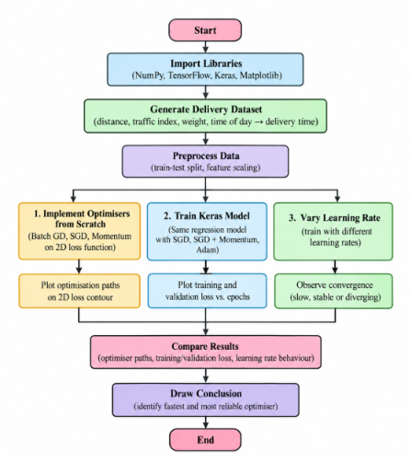

4. Code :

import numpy as np

import matplotlib.pyplot as plt

import tensorflow as tf

from sklearn.model_selection import train_test_split

from sklearn.preprocessing import StandardScaler

from tensorflow.keras import Sequential

from tensorflow.keras.layers import Dense

from tensorflow.keras.optimizers import SGD, Adam

np.random.seed(42)

tf.random.set_seed(42)

A = np.array([[4.0, 0.0],

[0.0, 1.0]])

def loss_function(theta):

return 0.5 * theta.T @ A @ theta

def gradient(theta):

return A @ theta

initial = np.array([2.0, 2.0])

learning_rate = 0.1

iterations = 40

theta = initial.copy()

gd_path = [theta.copy()]

for i in range(iterations):

theta = theta - learning_rate * gradient(theta)

gd_path.append(theta.copy())

theta = initial.copy()

sgd_path = [theta.copy()]

rng = np.random.default_rng(42)

for i in range(iterations):

noise = rng.normal(0, 0.5, 2)

grad = gradient(theta) + noise

theta = theta - learning_rate * grad

sgd_path.append(theta.copy())

theta = initial.copy()

velocity = np.zeros(2)

momentum_path = [theta.copy()]

beta = 0.9

rng = np.random.default_rng(42)

for i in range(iterations):

noise = rng.normal(0, 0.5, 2)

grad = gradient(theta) + noise

velocity = beta * velocity + grad

theta = theta - learning_rate * velocity

momentum_path.append(theta.copy())

x = np.linspace(-2.5, 2.5, 100)

y = np.linspace(-2.5, 2.5, 100)

X, Y = np.meshgrid(x, y)

Z = 2 * X**2 + 0.5 * Y**2

plt.figure(figsize=(9, 6))

plt.contour(X, Y, Z, levels=25)

plt.plot(*np.array(gd_path).T, 'o-', label='Batch GD')

plt.plot(*np.array(sgd_path).T, 'x-', label='SGD')

plt.plot(*np.array(momentum_path).T, 's-', label='Momentum')

plt.xlabel("Theta 1")

plt.ylabel("Theta 2")

plt.title("Optimizer Paths on 2D Loss Contour")

plt.legend()

plt.grid()

plt.show()

n = 1000

distance = np.random.uniform(1, 30, n)

traffic = np.random.uniform(1, 10, n)

weight = np.random.uniform(1, 20, n)

time_of_day = np.random.uniform(0, 24, n)

delivery_time = (

8

+ 2.5 * distance

+ 3.0 * traffic

+ 0.8 * weight

+ 0.5 * np.abs(time_of_day - 13)

+ np.random.normal(0, 3, n)

)

X = np.column_stack((

distance, traffic, weight, time_of_day

))

y = delivery_time.reshape(-1, 1)

X_train, X_test, y_train, y_test = train_test_split(

X, y, test_size=0.2, random_state=42

)

x_scaler = StandardScaler()

y_scaler = StandardScaler()

X_train = x_scaler.fit_transform(X_train)

X_test = x_scaler.transform(X_test)

y_train = y_scaler.fit_transform(y_train)

y_test = y_scaler.transform(y_test)

def create_model():

model = Sequential([

tf.keras.Input(shape=(4,)),

Dense(32, activation='relu'),

Dense(16, activation='relu'),

Dense(1)

])

return model

base_model = create_model()

initial_weights = base_model.get_weights()

optimizers = {

"SGD": SGD(learning_rate=0.01),

"SGD + Momentum": SGD(

learning_rate=0.01, momentum=0.9

),

"Adam": Adam(learning_rate=0.01)

}

histories = {}

results = {}

for name, optimizer in optimizers.items():

model = create_model()

model.set_weights(initial_weights)

model.compile(

optimizer=optimizer,

loss='mse',

metrics=['mae']

)

history = model.fit(

X_train,

y_train,

epochs=80,

batch_size=32,

validation_data=(X_test, y_test),

verbose=0

)

histories[name] = history.history

test_loss, test_mae = model.evaluate(

X_test, y_test, verbose=0

)

results[name] = (test_loss, test_mae)

print(name)

print("Final Training Loss:",

round(history.history['loss'][-1], 4))

print("Final Validation Loss:",

round(history.history['val_loss'][-1], 4))

print("Test MAE:", round(test_mae, 4))

print()

plt.figure(figsize=(9, 6))

for name, history in histories.items():

plt.plot(

history['loss'],

label=name

)

plt.xlabel("Epochs")

plt.ylabel("Training Loss (MSE)")

plt.title("Optimizer Comparison - Training Loss")

plt.legend()

plt.grid()

plt.show()

plt.figure(figsize=(9, 6))

for name, history in histories.items():

plt.plot(

history['val_loss'],

label=name

)

plt.xlabel("Epochs")

plt.ylabel("Validation Loss (MSE)")

plt.title("Optimizer Comparison - Validation Loss")

plt.legend()

plt.grid()

plt.show()

learning_rates = [0.0001, 0.01, 1.0]

lr_histories = {}

for lr in learning_rates:

model = create_model()

model.set_weights(initial_weights)

model.compile(

optimizer=SGD(learning_rate=lr),

loss='mse'

)

history = model.fit(

X_train,

y_train,

epochs=40,

batch_size=32,

validation_data=(X_test, y_test),

verbose=0,

callbacks=[

tf.keras.callbacks.TerminateOnNaN()

]

)

lr_histories[lr] = history.history['loss']

final_loss = history.history['loss'][-1]

print("Learning Rate:", lr)

print("Final Training Loss:", round(final_loss, 4))

if not np.isfinite(final_loss) or final_loss > 10:

print("Observation: Possible divergence")

elif final_loss > 0.1:

print("Observation: Slow convergence")

else:

print("Observation: Converging")

print()

plt.figure(figsize=(9, 6))

for lr, losses in lr_histories.items():

plt.plot(losses, label=f"LR = {lr}")

plt.xlabel("Epochs")

plt.ylabel("Training Loss (MSE)")

plt.title("Effect of Learning Rate on Convergence")

plt.legend()

plt.grid()

plt.show()

5. Output
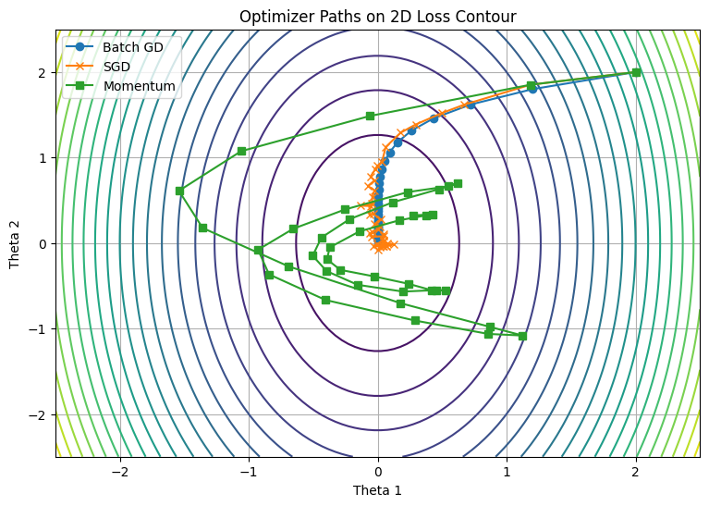
SGD
Final Training Loss: 0.0183
Final Validation Loss: 0.0226
Test MAE: 0.1235
SGD + Momentum
Final Training Loss: 0.0147
Final Validation Loss: 0.0207
Test MAE: 0.116
Adam
Final Training Loss: 0.0163
Final Validation Loss: 0.0241
Test MAE: 0.1248

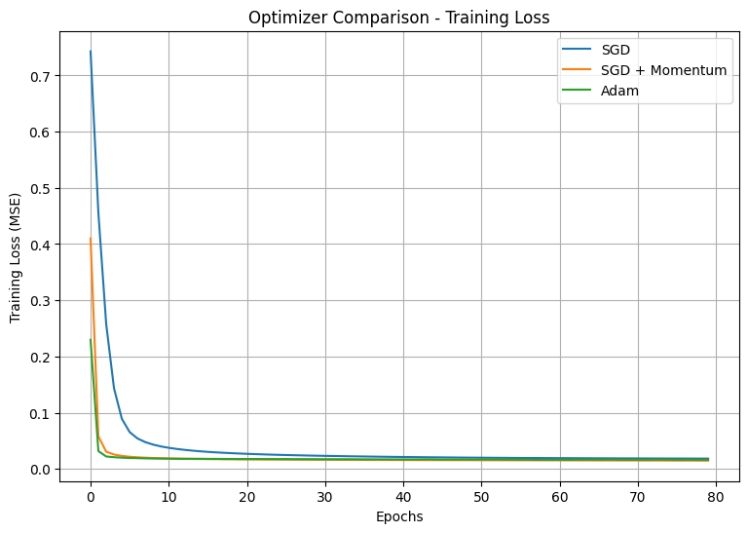
Learning Rate: 0.0001
Final Training Loss: 0.7626
Observation: Slow convergence
Learning Rate: 0.01
Final Training Loss: 0.0214
Observation: Converging
Learning Rate: 1.0
Final Training Loss: 1.5119360729946484e+24
Observation: Possible divergence
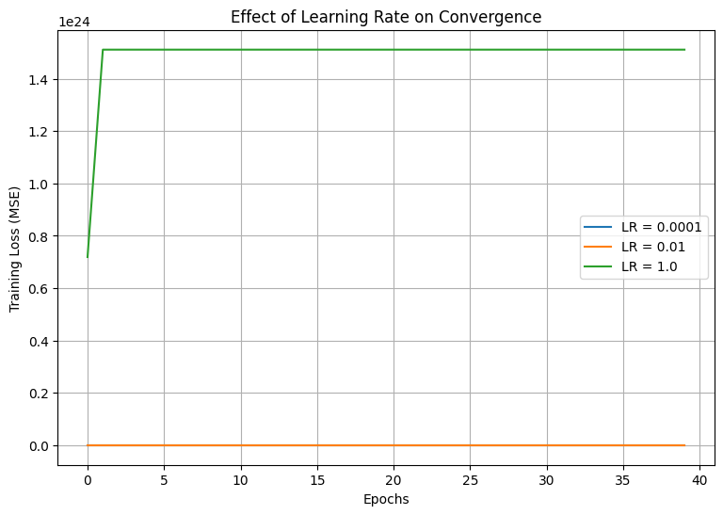

6. Result
Batch GD, SGD, Momentum and Adam were successfully implemented and compared. Their convergence paths, training losses and learning-rate effects were analyzed. Adam generally showed faster and more stable convergence than basic SGD.

